## **Part 1: Access a Cisco Switch through the Serial Console Port**

## **Step 1: Display the switch IOS image version.**

### Step 2: Install and investigate the PC.

### Step 3: Connect the switch and PC using a rollover console cable.

### Step 4: Configure the Packet Tracer Terminal program to establish a console session with the switch.

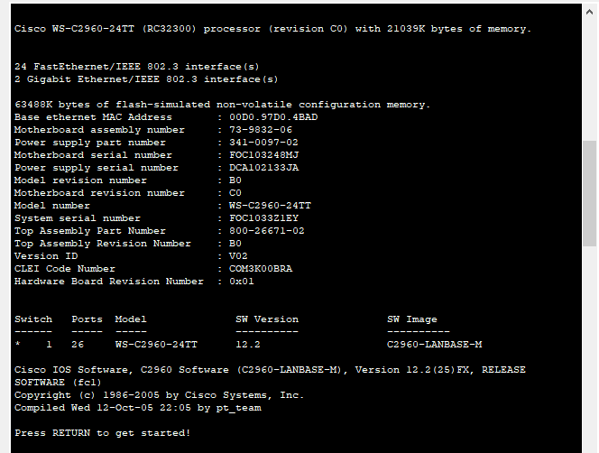

## **Part 2: Display and Configure Basic Device Settings**

## **Step 1: Display the switch IOS image version.**

While you are in the user EXEC mode, use the **show version** command to display the IOS version for the switch.

Switch> **show version**

Question:

Which IOS image and version is currently in use by the switch?

IOS : C2960-LANBASE-M

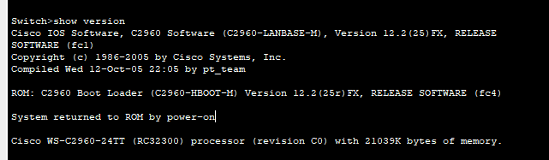Version: C2960-LANBASE-M

### Step 2: Configure the clock.

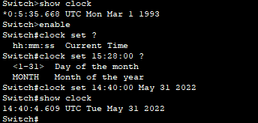

## **Part 3: Access a Cisco Router Using a Mini-USB Console Cable**

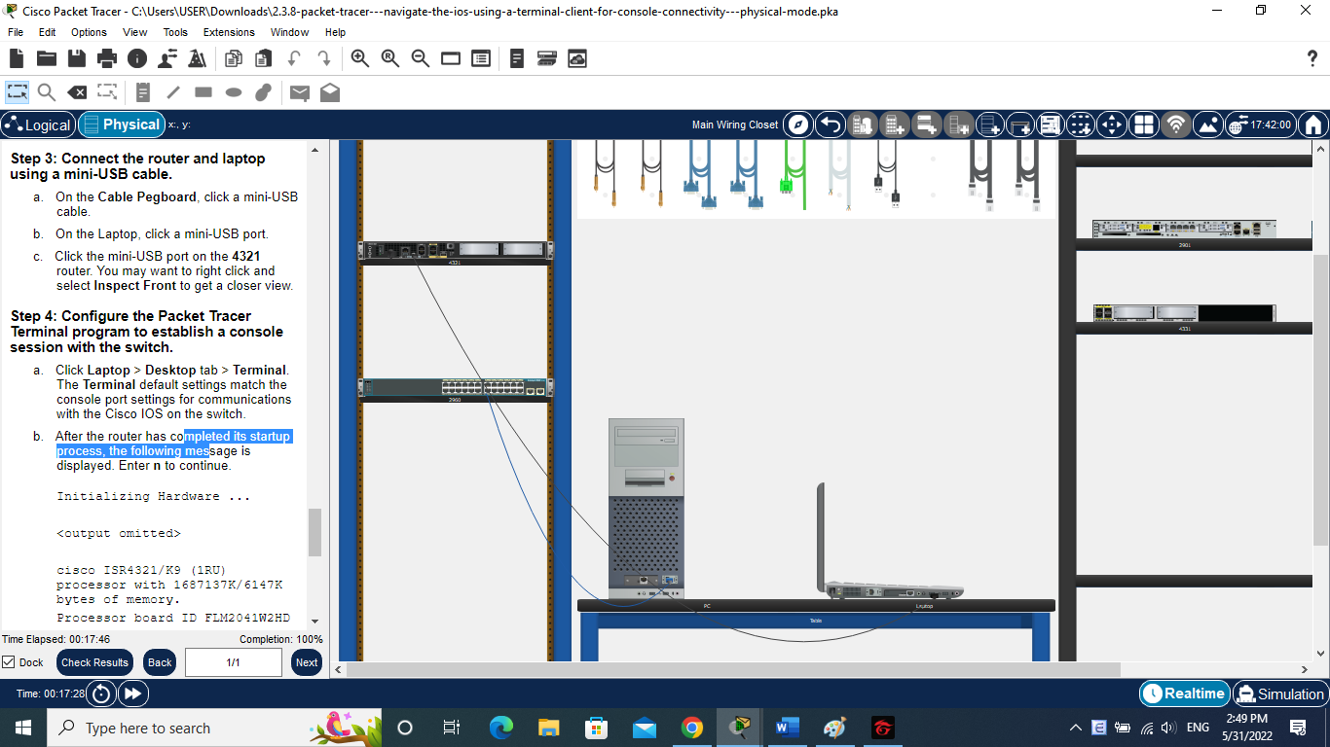

# **Reflection Question**

1. **How do you prevent unauthorized personnel from accessing the Cisco device through the console port?**

* User create login password in line configuration as well as set password in previllege access mode
* Physically secure

2.      **What are the advantages and disadvantages of using the serial console connection compared to the USB console connection to a Cisco router or switch?**

- It is determined by the ports available in each laptop, switch, and router. It is easy to connect an old computer with a serial connection to a Cisco router or switch. Cisco Switches do not have USB ports, thus if you wish to connect to one, you'll need a laptop with a serial port or a USB to serial port converter. Because it has both a serial and a USB port, it is easier for us to connect than a Cisco router.